The Basics of Buddhism

The Four “Noble Truths”
1. Suffering exists (Dukkha).
2. We suffer because we are attached to things.
3. We cease suffering by releasing our attachment.
4. We release our attachment by following the “noble” eight-fold path (Magga).

The Noble Eight-fold Path
- The Right View
- The Right Intention
- The Right Speech
- The Right Action
- The Right Livelihood
- The Right Effort
- The Right Mindfulness
- The Right Concentration

The Dharma wheel is an 8-spoked wheel representing the Eight-fold path. It is a symbol frequently found in Buddhism. It serves as a reminder of the Eight-fold path.

Buddhism is more of a philosophy than a religion. Even an atheist (one who does not believe that any kind of God exists), can be a Buddhist. The reason being is because Buddhism is a way to live, rather than an explanation of life. When talking with someone who is a Buddhist, explain to them how Buddhism fails under its own weight (see Bootstraps and Buddhism, to the right), and that suffering will never cease. Therefore, we must learn to deal with suffering in a different manner.
The 3 Fundamental
Laws of Logic

The Law of Identity: A = A. This simply just says that whatever something is, it cannot be something else. It is itself.

The Law of Non-contradiction: A ≠ ¬A. This means that a claim cannot be both true and false in the same sense at the same time. For example, a woman cannot be both pregnant and not pregnant at the same time.

The Law of Excluded Middle: A v ¬A. This law means that any truth claim is either true or false. There is no other option.

From these three fundamental laws of logic, one can discover which claims are true and which claims are false.

Bootstraps and Buddhism
Buddhism in the basics, to the left, teaches that people suffer, and that in order to not suffer, one must release attachment to things, whether it is our cars, toy poodles, record collection, or spouses. The problem with this is that in order to be unattached, one must depend on one’s own strength and power to not be attached to things. Essentially, one must pull himself up by his own bootstraps.
Another similar problem is that one must be attached to Buddhism in order to not have any attachment, which is the cause of suffering. Buddhism, then, is self-defeating and circular in reasoning because one must be attached to Buddhism in order to release all attachments. If attachment is the cause of suffering, yet I need to be attached to Buddhism, then I am still suffering by being attached to Buddhism. This violates the Law of Non-contradiction. It cannot be both true and not true at the same time. It is either true that releasing attachment will end suffering, or it is false. Also, it is either true that Buddhism will end suffering or it is false. The law of Non-contradiction tells us that this is not the case.
Buddhism teaches that suffering is the main problem with the world, but does not consider that maybe it is selfishness, which this idea seems to come from.

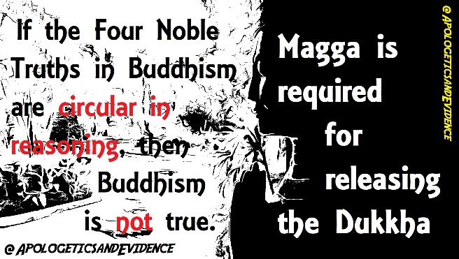

What does the Bible say?
The following verses give alternative answers to the eight-fold noble path.
1. Jesus is the way the truth and the life; no one comes to the Father but through Him (John 14:6).
2. Jesus says, Love God with all your heart, soul, and mind; and love your neighbor as yourself (Matthew 22:36-40).
3. Jesus says, “I tell you that everyone will have to give account on the day of judgment for every empty word they have spoken” (Matthew 12:36).
4. Jesus said, “Greater love has no one than this: that he lay down his life for his friends” (John 15:13).
5. “Is there any God besides me? No, there is no other Rock; I know not one” (Isaiah 44:8).
6. “These three remain: faith, hope, and love. But the greatest of these is love” (1 Corinthians 13:13.
7. “Finally, brothers, whatever is true, whatever is honorable, whatever is just, whatever is pure, whatever is lovely, whatever is commendable, if there is any excellence, if there is anything worthy of praise, think about these things” (Philippians 4:8).
8. “It is appointed unto men once to die and then comes the judgment” (Hebrews 9:27).

Good questions to ask Buddhists:
Ahimsa is the practice of not harming any living being, to which all Buddhists adhere. Ask, “How does it make you feel when you kill a mosquito that is in the act of sucking your blood?”
Isn’t having a lack of hope more of a problem than experiencing suffering?
Is suffering always a bad thing to experience?
Can’t we become better people through our suffering? Doesn’t it often make us stronger?
Who is it that judges karma?
Do we have any real evidence that reincarnation has ever taken place?

The True Hope. Buddhism offers no true hope. The only hope is that if one believes in reincarnation, that they will either reach nirvana (the Buddhist idea of heaven), or that they will be reincarnated into something better than before. On the other hand, if the Buddhist does not believe in reincarnation, then to death is all they have to look forward.
Jesus offers something greater: Eternal life! Buddhism acknowledges that there is right and wrong and that it must be judged. This is a good start. The Bible teaches that all will come to the place of judgment, but that those who have Jesus (1 John 5:11-12), will not fall under this judgment because Jesus took their sins (moral failures) away (Ephesians 2:8-9; Romans 6:23; John 1:29). This is where our expectant hope lies as followers of Christ. In Jesus alone we find real meaning, value and purpose for our lives. He desires a personal relationship with all people. “For God so loved the world that He gave His only Son that whoever believes in Him will not perish, but will have eternal life” (John 3:16).

For Further Study:

Neighboring Faiths, by Winfried Corduan
For more information and material, visit:
https://apologeticsandevidence.blogspot.com/

https://apologeticsandevidence.blogspot.com/2017/08/insufficient-buddhism.html

www.facebook.com/ApologeticsAndEvidence/

(Permission is granted to make copies of this pamphlet and to distribute them, provided this is done free of Charge and without altering the content.)

Sharing the Gospel with a Buddhist

“Contend for the faith that was once
for all delivered to the saints.”
~Jude 3

